**5.09 Stock Filter and Sort**

Total Points: 45

# **Instructions**

**For this assignment, you will be looking up stock information and putting it into a spreadsheet. Then, you’ll perform sorting and filtering in your stock spreadsheet. By the end of this task, you should have 3 files:**

**1.** **Stock Spreadsheet: contains the stock info you gather and enter**

**2.** **Stock Spreadsheet – Sort: the file where you sorted the stock information**

**3.** **Stock Spreadsheet – Filter: the file where you filtered the stock information**

**You will submit the last two files to the dropbox at the end of this assignment.**

# **Gathering Stock Information**

Go to the New York Stock Exchange (NYSE) Listings Directory linked on the Task page. Research 15 companies like Wal-mart, Target, Microsoft, etc.

For each of the 15 companies, you need to obtain:

* the name of the company,
* their stock symbol, and
* the current stock value.

# **Setting Up Your Spreadsheet**

Organize this data in a spreadsheet, creating the following column headings:

* Company Name,
* Company Symbol,
* Stock Value,
* Number of Shares, and
* Your Stock Value.

These headings should go along row 1 from A1 to E1.

Enter the stock information you gathered from the NYSE into the spreadsheet, including names, symbols, and value of stock for all 15 companies. Then, put 50 or 100 shares for each stock in the "Number of Shares" column. Do not make all of the "Number of Shares" 100 or 50; instead, mix it up.

*Note: You will be using the ‘Number of Shares’ column (D) in a formula, so enter numbers only, not words.*

· *Incorrect example: 50 shares*

· *Correct example: 50*

Next, create a formula that will calculate "Your Stock Value" (in column E) for each company in which you own stock. *Hint: The formula will involve multiplying.*

Save this file as **Stock Spreadsheet**.

# **Part 1: Stock Sort**

Now you’re going to sort the information on this spreadsheet. Follow the steps below.

1. Highlight the rows and columns that contain the information you entered. Then select the funnel looking key. Click in the first column and sort A-Z.

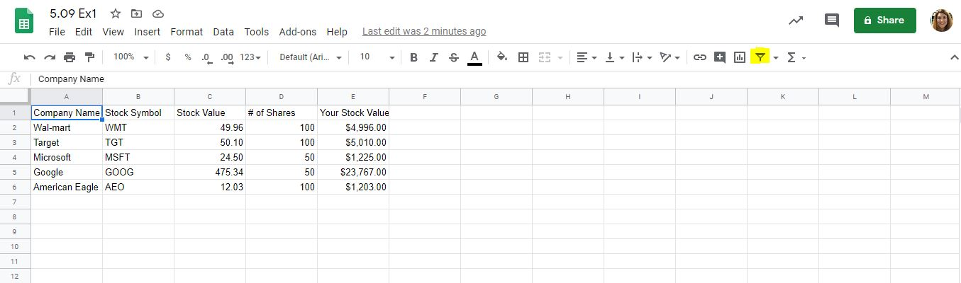

1. Find the **Sort icon**
2. Click on the **Sort** icon.
3. Select sort **A-Z**.
4. Notice how your worksheet changed.
5. Now select the **Sort** icon.
6. Select sort **Z-A**.
7. Notice how the worksheet changed.
8. Now select the **Sort** icon.
9. Select **Custom Sort**.
10. Sort by “Company Name” and do not change the other two fields (keep the default settings).
11. Click the “Add Level” button.
12. Select “Stock Value” in the **Then By** box.
13. Select the “Largest to Smallest” option in the **Order** box.
14. Select **OK**.
15. Save the file as **Stock Spreadsheet – Sort**.
16. Submit this file to the dropbox.

# **Part 2: Stock Filter**

Now you’re going to filter the information on this spreadsheet. Follow the steps below.

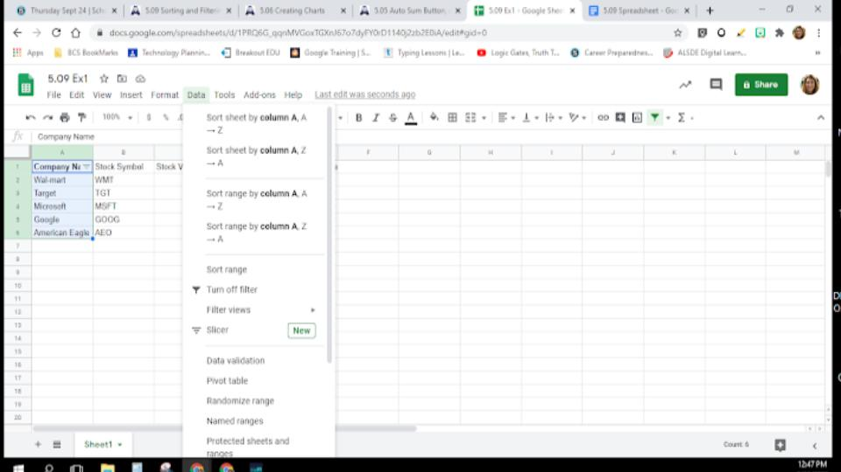

1. Highlight the rows and columns that contain the information you entered.

2. Look for the **Sort & Filter icon A-Z** with a funnel beside it on the Home tab.

3. Click on the icon to open the options.

4. Click on **Filter**.

Turn in when finished.